CREATE TABLE sales (

"customer_id" VARCHAR(1),

"order_date" DATE,

"product_id" INTEGER

);

INSERT INTO sales

("customer_id", "order_date", "product_id")

VALUES

('A', '2021-01-01', '1'),

('A', '2021-01-01', '2'),

('A', '2021-01-07', '2'),

('A', '2021-01-10', '3'),

('A', '2021-01-11', '3'),

('A', '2021-01-11', '3'),

('B', '2021-01-01', '2'),

('B', '2021-01-02', '2'),

('B', '2021-01-04', '1'),

('B', '2021-01-11', '1'),

('B', '2021-01-16', '3'),

('B', '2021-02-01', '3'),

('C', '2021-01-01', '3'),

('C', '2021-01-01', '3'),

('C', '2021-01-07', '3');

CREATE TABLE menu (

"product_id" INTEGER,

"product_name" VARCHAR(5),

"price" INTEGER

);

INSERT INTO menu

("product_id", "product_name", "price")

VALUES

('1', 'sushi', '10'),

('2', 'curry', '15'),

('3', 'ramen', '12');

CREATE TABLE members (

"customer_id" VARCHAR(1),

"join_date" DATE

);

INSERT INTO members

("customer_id", "join_date")

VALUES

('A', '2021-01-07'),

('B', '2021-01-09');

1. What is the total amount each customer spent at the restaurant?

SELECT customer_id, COUNT(order_date) as 'Total Days Visited'

FROM sales

GROUP BY customer_id

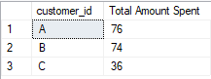

1. How many days has each customer visited the restaurant?

SELECT customer_id, COUNT (DISTINCT order_date)as "Total Days Visted"

FROM sales

GROUP BY customer_id;

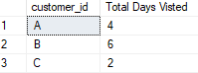

1. What was the first item from the menu purchased by each customer?

SELECT DISTINCT (s.customer_id),s.product_id, s.order_date, m.product_name

FROM sales as s

INNER JOIN menu as m on m.product_id = s.product_id

ORDER BY s.order_date

offset 0 rows

fetch next 4 rows only

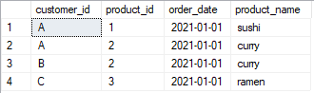

1. What is the most purchased item on the menu and how many times was it purchased by all customers?

SELECT (count(s.product_id)) as total_purchased,product_name

FROM sales as s

INNER JOIN menu as m on s.product_id = m.product_id

GROUP BY s.product_id, product_name

ORDER BY total_purchased DESC

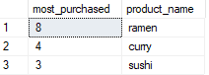

1. Which item was the most popular for each customer?

SELECT DISTINCT(s.customer_ID),(COUNT(s.product_id)) AS total_purchased, product_name

FROM sales AS s

JOIN menu AS m

ON s.product_id = m.product_id

GROUP BY s.customer_id, product_name

ORDER BY total_purchased DESC

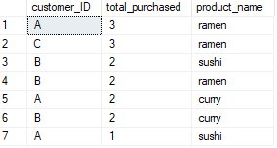

1. Which item was purchased first by the customer after they became a member?

SELECT s.customer_id,s.order_date, b.join_date, s.product_id

FROM sales AS s

JOIN members AS b

ON s.customer_id = b.customer_id

WHERE s.order_date >=b.join_date

ORDER BY s.order_date

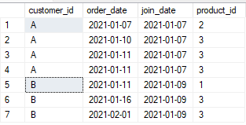

1. Which item was purchased just before the customer became a member?

SELECT s.customer_id,s.order_date, b.join_date, s.product_id

FROM sales AS s

JOIN members AS b

ON s.customer_id = b.customer_id

WHERE s.order_date < b.join_date

ORDER BY s.order_date

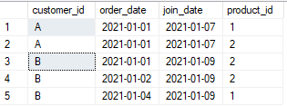

1. What is the total items and amount spent for each member before they became a member?

SELECT s.customer_id,count(distinct s.product_id) as menu_item, sum(m.price) as total_cost

FROM sales AS s

JOIN members AS b

ON s.customer_id = b.customer_id

JOIN menu AS m

ON s.product_id = m.product_id

WHERE s.order_date < b.join_date

GROUP BY s.customer_id



1. If each $1 spent equates to 10 points and sushi has a 2x points multiplier - how many points would each customer have?

SELECT *,

CASE

WHEN product_id = 1 THEN price * 20

ELSE price * 10

END AS points

FROM menu as price_points

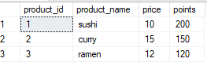

SELECT s.customer_id,

SUM(

CASE

WHEN m.product_name = 'sushi' THEN 20 * price

ELSE 10 * PRICE

END

) AS Points

FROM sales as s

JOIN menu as m

ON s.product_id = m.product_id

GROUP BY

s.customer_id

ORDER BY

s.customer_id;

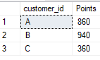

1. In the first week after a customer joins the program (including their join date) they earn 2x points on all items, not just sushi - how many points do customer A and B have at the end of January

Same code as above but limiting the date

SELECT

s.customer_id,

SUM(

CASE

WHEN m.product_name = 'sushi' THEN 20 * price

WHEN order_date BETWEEN '2021-01-07' AND '2021-01-14' THEN 20 * price

ELSE 10 * PRICE

END

) AS Points

FROM sales as s

JOIN menu as m

ON s.product_id = m.product_id

JOIN members as b

ON b.customer_id = s.customer_id

GROUP BY

s.customer_id

ORDER BY

s.customer_id;